DOS Attack Case Study
M BHAVYA TEJASWI SHASHIDHAR
CYBER SECURITY CYBER SECURITY MENTOR
TAH1702262005 TEKS ACADEMY
TEKS ACADEMY 9603343287
7330810326
1.Abstract:
- The aim of this project is to simulate and analyze various DoS attacks on the laboratory environment. The main objective of the research is to investigate the effects of various types of DoS attacks on system availability at the network layer, transport layer, and application layer.
- An experiment was done by creating the lab environment through the use of VMware Workstation, where Kali Linux was used for attacks and Ubuntu Server running Apache Web server for target system.
- Three main DoS attacks have been demonstrated in this lab session as follows:
  - ICMP Flood (Volumetric Attack)
  - TCP SYN Flood (Protocol-Based Attack)
  - HTTP Flood Using Slow Loris (Application Layer Attack)
- Tools like hping3 and Slow Loris have been used to execute the attacks on systems, and network traffic was analyzed with the help of tcp dump and other performance tools.
- Some key IoCs observed during the process include the following:
  - High rate of ICMP packets causing network saturation
  - Many SYN packets with incomplete TCP handshake
  - High number of HTTP connections and keep-alives
- Their efficacy was confirmed by analyzing the system’s performance prior to and post their deployment, revealing decreased amounts of malicious traffic and increased server stability.
- The current project gives learners the opportunity to apply theoretical knowledge in practice regarding such key areas as network security, packet analysis, and attacks detection and prevention.
2. Problem Statement
- Given the growing reliance on internet applications and online services, system availability has emerged as one of the significant issues in cybersecurity.
- In this regard, denial-of-service attacks can be considered a serious threat as they bombard the targeted system with illegitimate network traffic, causing it to stop working for some time.
- ICMP flood, TCP SYN flood, and HTTP flood are among the many DoS attack variants that operate at various network stack levels and utilize system vulnerabilities to achieve their purpose.
- While volumetric attacks use up network bandwidth, protocol-based attacks take advantage of connection management, and application layer attacks imitate legitimate user activities.
- The main issue lies in the differentiation of normal traffic from malicious traffic, particularly when it comes to application layer attacks, which are designed to resemble valid traffic patterns.
- Most companies are often unaware of how the attacks are carried out and how they affect system performance, including CPU utilization, network traffic, and connection management.
- Consequently, the existing detection methods may fail to identify such attacks in their early stages without further analyzing their traffic patterns and behaviors.
- There is also a necessity to examine how various defense mechanisms like firewalls, rate limiting, and connections can defend against these attacks.
- Thus, it is necessary to experiment with several DoS attack vectors to comprehend their behavior and design appropriate solutions for mitigating such attacks.
- This project intends to cater to this problem by giving an opportunity to investigate DoS attacks and learn how to defend against them.
The Solution: Why we Need an Automated Fix
- Detection and mitigation of DoS attacks manually take up valuable time and resources, which is particularly problematic during fast and intense attacks.
- For example, DoS attacks, including ICMP flood, TCP SYN flood, and HTTP flood, create an enormous amount of data within seconds, which would be impossible to manage in real time without automation.
- Additionally, the type of the attack affects the layer attacked: network, transport, and application. This fact necessitates constant monitoring and prompt decision-making, something that cannot be done manually.
- Attackers who perform application-layer attacks, such as HTTP flood, use sophisticated methods to disguise their malicious actions, making their identification only possible through the help of automation.
- Automated solutions enable constant monitoring and detection of unusual traffic, including high data transfer rates, partial TCP handshakes, or too many connections made.
- Automated techniques can be used to apply rate limiting, firewall rules, and connection restrictions to mitigate DoS attack threats.
- Automation improves efficiency by decreasing response time and eliminating human error and inconsistency in the process.
- In practice, SOC uses automation and scripts in order to handle large DoS attacks effectively.
3. Project Objectives
- To learn about DoS attacks and the effect they can have on availability and performance of systems.
- To understand different kinds of DoS attacks including ICMP Flood (volume-based), TCP SYN Flood (protocol-based), and HTTP Flood (application-based).
- To build a controlled virtual environment consisting of VMware Workstation with Kali Linux as the attacking machine and Ubuntu Server as the target.
- To install a web server on the target machine and perform attacks on it.
- To capture and monitor traffic generated by DoS attacks and analyze the response from target systems.
- To detect signs of DoS attacks based on patterns, rate of packets sent and received, and any incomplete TCP handshake or large number of concurrent connections made.
- To distinguish normal traffic from malicious one.
- To protect against DoS attacks through security measures such as firewalls, limiting the rate of packet sending, enabling SYN cookies, and limiting maximum number of concurrent connections made.

4. Project Scope
- This project involves simulating and analyzing Denial of Service (DoS) attacks using a controlled virtual lab environment.
- This project will limit its focus on three specific types of DoS attacks: ICMP flood (a volumetric attack type), TCP SYN flood (protocol attack type), and HTTP flood (application layer attack type).
- The simulation of the three DoS attacks will be performed in a virtual environment that has been configured using VMware Workstation. The attacker machine will run Kali Linux while the target machine will run Ubuntu Server.
- The target machine will run an Apache web server that will provide services for simulating actual scenarios of availability of services.
- Network traffic monitoring and analysis during the attacks will involve the use of utilities like tcpdump and system level monitoring utilities.
- Attacks detection will involve observing abnormal patterns in the traffic as well as other indications of traffic anomalies like high packet rate, incomplete handshake, and too many concurrent connections.
- Implementation of DoS defense will be performed by implementing some basic DoS defenses including iptables firewall, rate limiting, SYN cookies, and connection limiting.
What's Not Included
- The project does not have the simulation of large-scale Distributed Denial of Service (DDoS) attack where there are more than one attacking host or bots that participate.
- Security solutions provided by cloud-based systems such as content delivery networks (CDN), load balancers, or DDoS mitigation service are not considered.
- There is no implementation of advanced SIEM technologies (such as enterprise log correlation and alerting).
- Real-time automatic detection systems based on machine learning and artificial intelligence are not incorporated in the scope of this project.
- The project does not conduct deep packet inspections through advanced visualization tools since the analysis mainly uses the traditional tcp dump software.
- This project does not conduct the exploitation of real-world vulnerabilities or any live production system due to its unethical nature.
- Hardware mitigation solutions such as intrusion prevention systems (IPS) or any other network appliance are not considered in this project.
Key Requirements & Assumptions
- The system relies on the presence of two virtual machines - Kali Linux (attacker) and Ubuntu Server (target).
- Installation of the Apache web server on the target machine to conduct application layer attacks should take place.
- Use of tools such as hping3, Slow Loris, and tcpdump in the virtual laboratory setting is expected.
- System hardware capabilities are constrained by the lack of sufficient amount of CPU and RAM due to lab constraints.
- Attacks and their detection/mitigation are conducted in an isolated and controlled environment so that there is no risk of affecting other networks.
- The project is based upon the assumption of ethical hacking and forbids any test on real or production systems.
- Basic attack detection and prevention capabilities are applied in the project due to a lack of an enterprise network infrastructure.
What You'll Get
By the end of this project, we'll deliver a complete package:
- An explanation of various types of DoS attacks and how they affect availability.
- Experience in creating a simulated environment for conducting cyber security experiments using VMware Workstation and configuring both attacker and target systems.
- Knowledge of conducting ICMP, TCP SYN, and HTTP floods attacks using tools such as hping3 and Slow Loris.
- Ability to analyse traffic and detect signs of DoS attacks by examining traffic using tcp dump.
- Identification of IoCs such as elevated packets per second (pps), incomplete TCP handshakes, and too many connections.
- Ability to distinguish between normal traffic and DoS attacks through traffic volume, patterns, and other behaviour-based criteria.
- Implementation of simple countermeasures against DoS attacks, such as firewalls, rate limiting, SYN cookies, and connection limits.
5. Tools and Technologies Used
- VMWare was employed to create and maintain virtual machines within a lab setting.
- Kali Linux was adopted as the attacking machine to conduct various DoS attacks.
- Ubuntu Server was chosen as the target machine to deploy services and assess the effects of the attacks.
- Apache2 web server was installed on the target machine to mimic real-world web applications.
- hping3 software was utilized to conduct ICMP and TCP SYN floods.
- The Slow Loris program was adopted to conduct HTTP floods at the application level.
- Tcp dump utility was adopted to capture and analyse network packets during attack simulation exercises.
- System monitoring programs like top and htop were used to monitor system performance. ss command was adopted to check on network connections and sockets.
- Important Linux commands used:
- ip a - verify IP addresses and interfaces configuration in the system.
- Ping - verify connectivity between attacker and target machines.
- Curl command - verify the availability and responsiveness of the web server.
- Sudo apt update and Sudo apt install are used to ensure the latest updates and installation of the necessary software.
- Systemctl start/stop/status apache2 is used to control and monitor the Apache web server.
- Hping3 - launch ICMP and TCP SYN floods for the purposes of attack scenario.
- Slow Loris command - Simulate HTTP attacks by establishing multiple connections with the webserver.
- Tcpdump - capturing and analysing network packet information in different scenarios of attacks.
- Top and htop commands are used to monitor CPU usage and performance.
7. Deliverables
The deliverables are the final pieces you'll have once the project is finished. They're the concrete things you can show, use, and share to prove the project is complete and working. For this project, here's what you'll get:
i) Main Script
- Main script contains all the essential commands and settings required for launching DoS attacks and implementing the countermeasures.
ii) Schedule
- Schedule is a sequence of activities that will be carried out in order to complete the project from lab setup to analysis.
iii) Record
- Record consists of all the results obtained from the experiment. It includes command execution reports, screen captures, and analysis notes.
iv) Guide
- Guide is a set of instructions and explanations that will help in the process of carrying out the project activities.
v) Presentation
- Presentation is an organized representation of information contained in the project.
8. Project Implementation
Step 1. Icmp Attack
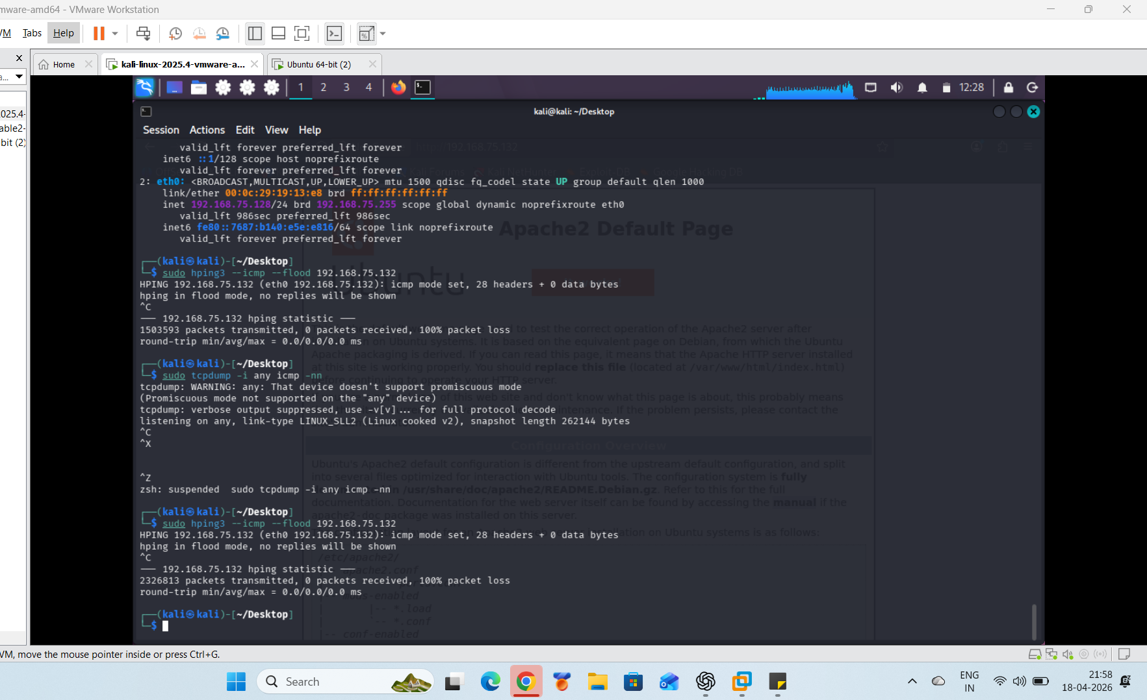

Step 2: Flood of packets in attacker system
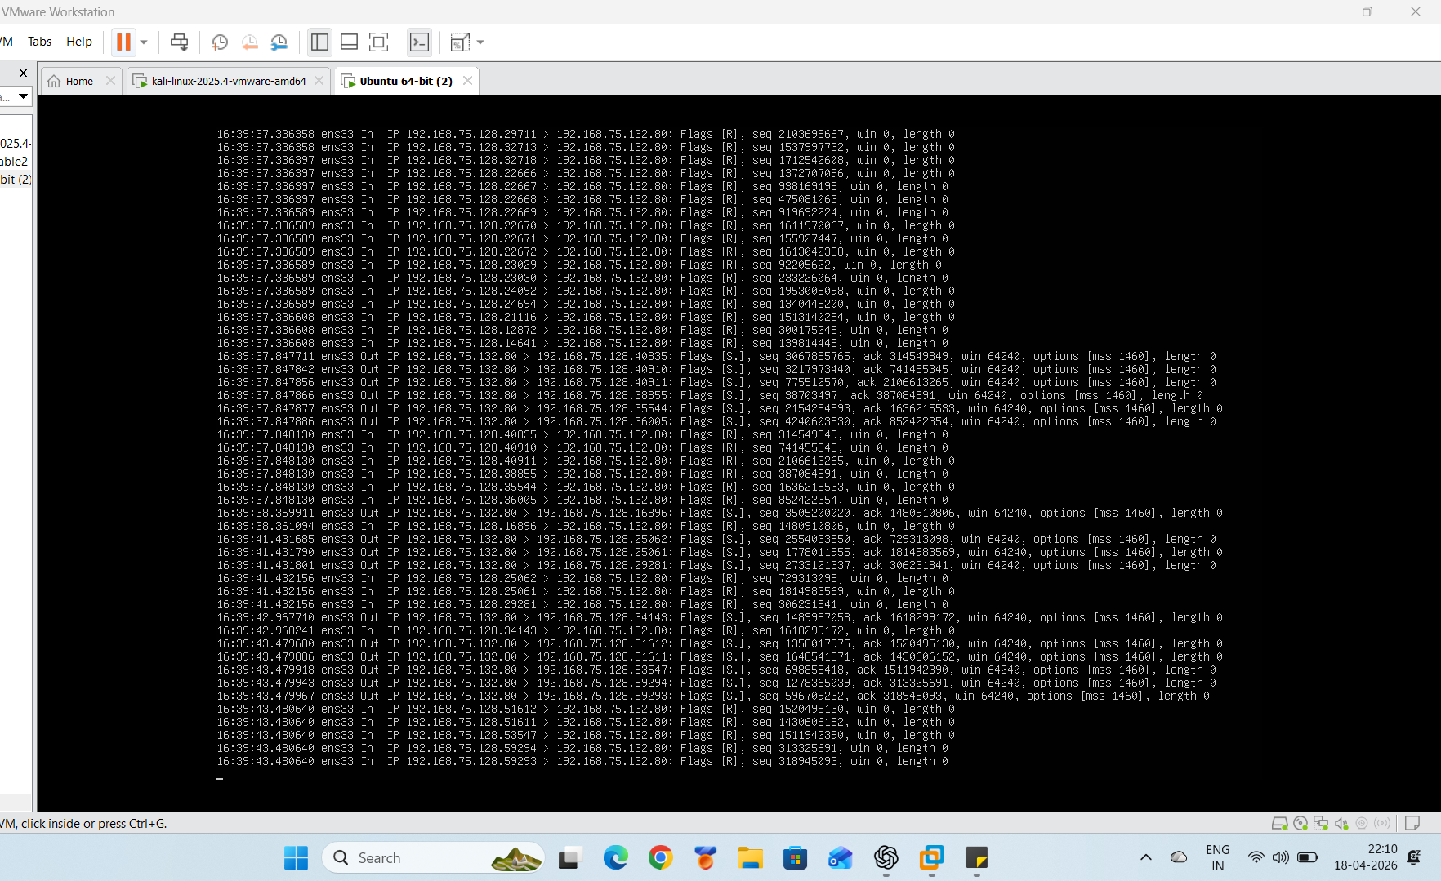

Step 3: CPU Usage
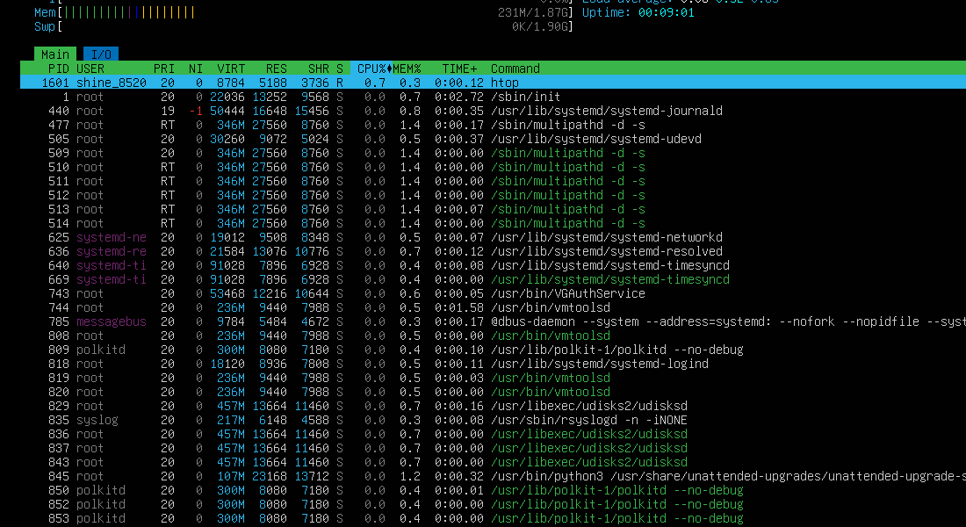

Step 4: Commands
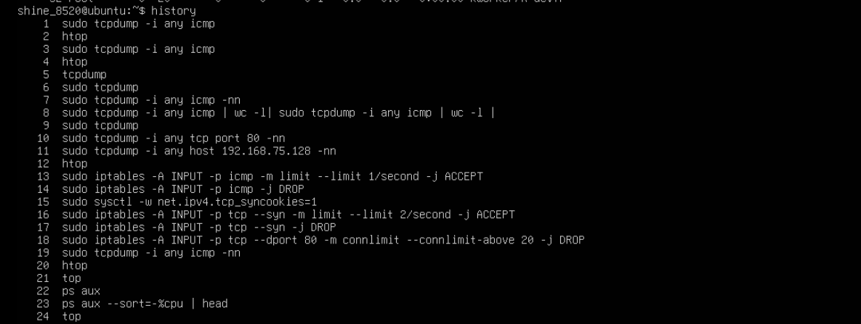
Step 5: SYN Attack
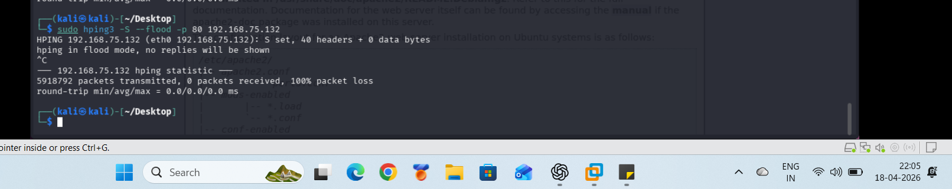
Step 6: CPU Usage
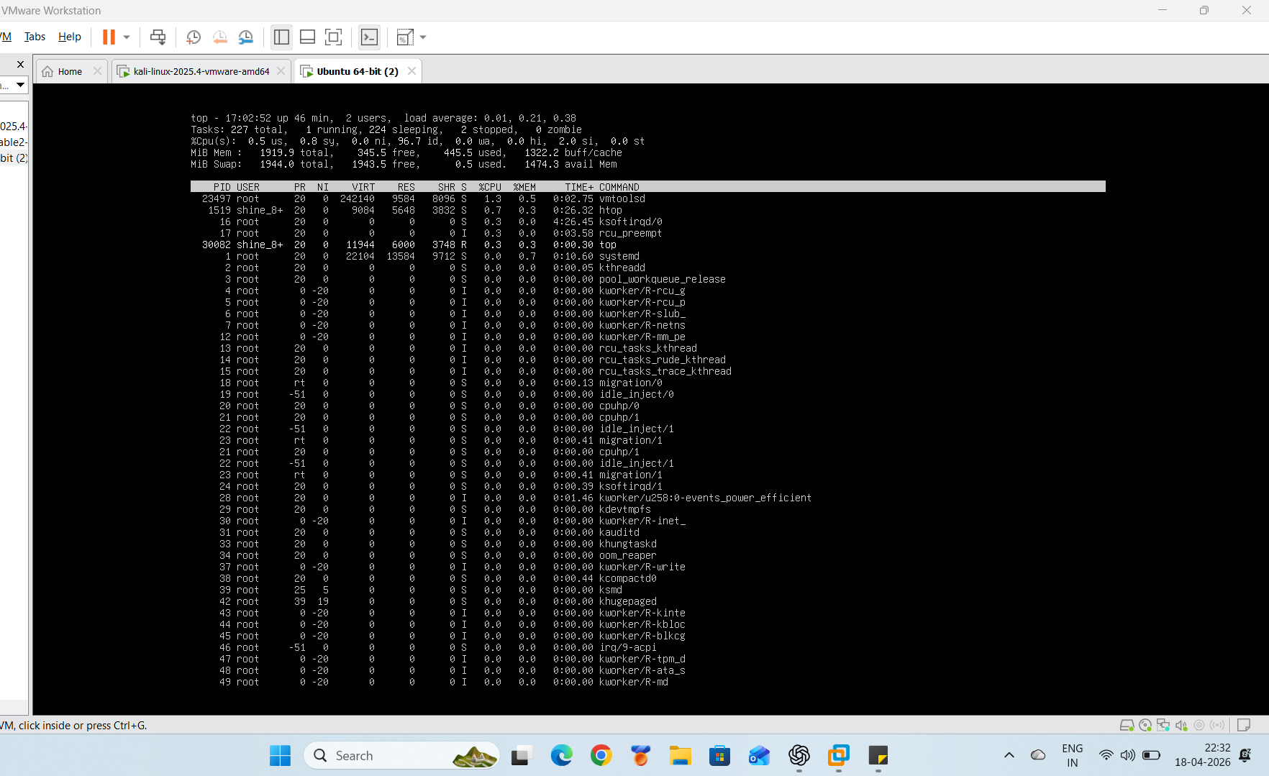

Conclusion: -
- The successful demonstration of the simulation and analysis of various types of DoS attacks including ICMP flood, TCP SYN flood and HTTP flood in the controlled environment of the laboratory was achieved.
- The impact of different types of attacks on network bandwidth, network connections, and resources at the application level could be easily understood.
- Practical demonstration of attacks by using different software including hping3 and Slow Loris gave an insight into the nature of attacks and their impact on the systems.
- The use of tcp dump tool to capture packets from the network helped in identifying the various patterns associated with attacks and IoCs.
- Differentiating between normal traffic and the malicious one depending upon its volume, pattern, and behavior was stressed in the project.
- The implementation of various defense mechanisms such as iptables rules, rate limiting, SYN cookies, and connection limits helped in mitigating the impact of the attacks on the network.
- There was a visible improvement in the performance of the systems, reduction in malicious traffic and steady performance of the web servers.
- The significance of timely identification and handling of the threat was learned from the project.
- The implementation gave practical exposure to network security, packet capturing, and various other concepts.

